Looseleaf Resource Type

* Condition 1: LDR ^.{6}[at][bis]
  + This looks for LDR:06= a or t (language material or manuscript language material) and LDR:07=b, i, or s (serial component part, integrating resource, or serial)
* Condition 2: AND 008 ^.{21}l
  + This looks for 008:21=l (ell) (updating loose-leaf)

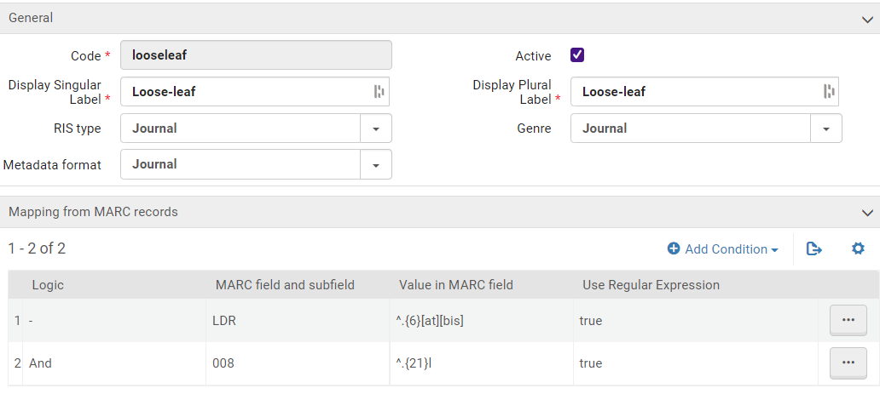

Once you’ve set a local resource type up, you’ll need to gather up your IZ-only bibs that are included in that type and run the “Recalculate Resource Types” job on them.  If you’re planning to apply multiple types at the same time, you can hold this step and run the job on ALL of your IZ-only bibs at once after you complete setup of all local resource types.